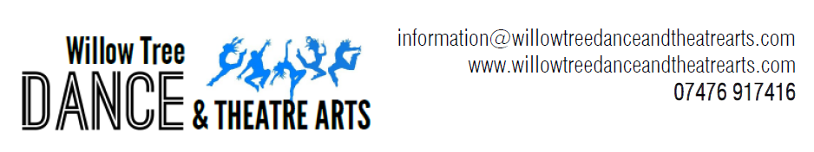
Dinky Dancers, Standard and Enhance Performing Arts Course

Dinky Dancers
Age 3-5 years
- Pre-Primary Ballet/Primary Ballet
- Funky Movers
- Tiny Tappers
£122 per term

Standard Performing Arts
Open to all
- Ballet
- Modern
- Singing
- Tap
£185 per term

Enhanced Performing Arts
Year 6+ By application only
Commitment to attend all of the following classes:-
- Ballet
- Modern/Senior Commercial
- Pointe (if applicable)
- Singing
- Contemporary
- Tap
- Acro/Stretch (Optional from school year 9)
- Musical Theatre
- Hip Hop
- Drama (Optional from school year 9)
Conditions of Application for Enhanced Performing Arts:-
By application/interview and class assessment only.
- Be year 6+
- Must attend all the classes listed above
- Commitment must be shown through regular attendance in class
- Fees paid on time
- Further classes, in addition to those listed above, are accessible by invitation
- Performing Arts students are the ambassadors for Willow Tree Dance and Theatre Arts and as such will set the example with the correct uniform, hair and general appearance at all times
- We have the right to withdraw the Enhanced Performing Arts offer if the above conditions are not met
£370 per term

